App-V 4.5 SP2 FAQ

Why should I upgrade my server infrastructure from 4.5 SP1 to SP2?
App-V 4.5 SP2 server provides enhanced failover protection and support for high availability scenarios for virtual applications. With SQL mirroring support App-V data-store will always be available, allowing administrators to quickly recover from disasters and/or recycle servers for maintenance. SQL mirroring will enable IT managers to design and run their infrastructure for virtual application scenarios that require high availability for provisioning and streaming.

Do I need to separate management server from the database?
The short answer is NO- separate management server and database is not a requirement; however, to fully utilize the capabilities of your infrastructure and build a scalable and available application virtualization system, it might make sense to separate the two. The SQL mirroring benefit is best achieved with separate servers even over geographically dispersed locations. See the infrastructure planning guides and the Server sizing whitepaper for more details.

Does SQL mirroring support SAN’s
YES. The SQL server supports SAN architecture and App-V merely uses the features supported out of the box. You can increase availability by providing complete or nearly complete database redundancy in the event of a disaster or planned upgrade with SQL mirroring. A high-availability solution does not always require proprietary hardware, is easy to set up and manage, and provides automatic client redirection in the event of a failure.

Are there any changes to the streaming server?
No, there are no changes to the streaming server in this specific release.

I do not want to deploy the HA features, do I still need to deploy the SP?
Yes, with the service pack you will be able to benefit from the incremental enhancements working around commonly encountered customer issues and be prepared to deploy HA features when the business requires it. For a full list of corrected issues see the Release Notes.

Can I update some servers to SP2 but leave others to SP1?
No you have to upgrade the entire infrastructure to one version. We recommend the Server infrastructure be on a standardized version.

Do I have to re-sequence my applications on upgrading?
No, you do not have to re-sequence your applications on upgrading to SP2 client or server infrastructure. SP2 does not apply to App-V 4.6 clients.
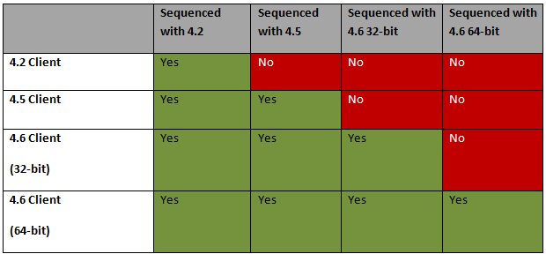

Why should I update my clients from 4.5 to 4.5 SP2 versus 4.6?
You should always run the latest version unless there is a compelling reason to stay on App-V 4.5 as there are many more capabilities in the newer versions that included customer feedback and known issue corrections.

Why do we not have any updates for 4.6 clients?
App-V 4.5 SP2 is aimed primarily at the Server infrastructure and 4.5 SP1 clients that could not migrate to App-V 4.6 but needed the support for Office 2010. You should try to upgrade to App-V 4.6 client if possible.

What Server OS versions can the App-V 4.5 SP2 Terminal Services Client be deployed to?
Windows Server 2003 Standard (SP1, SP2, R2, SP2+R2); Windows Enterprise Server 2003 (SP1, R2, SP2, SP2+R2); Windows Server 2003 Datacenter (SP1, R2, SP2, SP2+R2), Windows Server 2008 (Standard, Enterprise, Datacenter) See the system requirements for a complete list.

What operating systems can the App-V 4.5 SP2 Client be deployed to?
The App-V 4.5 client can be deployed to x86 Windows desktop operating systems: Windows XP Pro w/SP2, Windows XP w/SP3, Windows Vista RTM/SP1 (Business, Enterprise, Ultimate), Windows 7 (Business, Enterprise and Ultimate).
For x64 version of the operating system upgrade to App-V 4.6 clients. For more information see App-V 4.6 overview.

How do I upgrade from older versions of App-V
Before attempting to upgrade to Microsoft Application Virtualization 4.5 or later versions, any version prior to 4.1 must be upgraded to version 4.1. You should plan to upgrade your clients first, and then upgrade the server components.
Clients that have been upgraded to 4.6 will continue to work with Application Virtualization servers that have not yet been upgraded. If you are running App-V 4.5 or 4.5SP1 clients it is best to upgrade them to App-V 4.6. For more information about upgrading the system components, see Application Virtualization Deployment and Upgrade Considerations.

Why is App-V 4.5 SP2 not included in the MDOP Update?
App-V 4.5 SP2 will be included at the next MDOP update coming soon.

Why is App-V 4.5 SP2 being released to Microsoft update only?
App-V 4.5 SP2 will be available on Microsoft Update, Microsoft download center and MVLS on May 25 and will be included in the next scheduled MDOP refresh.

Where can I find App-V 4.5 SP2 on MVLS?
You can download App-V 4.5 SP2 from Microsoft Volume Licensing Site (MVLS).

